CALCULATIONS POLICY
(Written and Mental)

Calculations Policy

Our Mission Statement
Holy Trinity and S. Silas School was founded by the Church in 1847 to serve the community and to provide an education for every child in the area.

We offer all our children an education of the highest quality taught through the arts and lived through the principles and practice of the Christian faith. We provide a place where all children and adults know their contribution is valued and where they can develop their own faith in God and in one another.

We aim to help every child develop to their full potential, to achieve highly, succeed, and grow in confidence and abilities. Our inspiring curriculum provides all the skills every child will need for life, it develops their self-confidence, awakens their imagination and encourages them to think independently.

We value the diversity of backgrounds and cultures which enrich our life and help our school become the unique place it is. The life of our school is integral to that of the Parish: we both contribute to our local community and benefit from it in our achievements.
It is with this unity that we fulfil our school motto
‘Fortis in Fide’
‘Strong in the Faith’

Purpose

This policy outlines the teaching, organisation and management of the calculations methods taught and learnt at Holy Trinity and S. Silas Primary School. It also includes details of fluency objectives for each year group and visual representations to support the teaching and learning of mathematics.

Explanation

Teachers should cross reference with the Maths Policy and Camden Journey Planners and the ability and needs of the children to determine when these methods are to be taught.

Mental methods should be taught before written methods and mental methods must be taught in maths lessons. FAST maths sessions are for practising mental maths knowledge and skills to develop fluency (see fluency objectives for each year group).

Encourage children think carefully on how they will answer a mathematical problem.

They should consider: Can I do this in my head? What mental strategy would be most suitable with these numbers? If I can’t do it wholly in my head, what jottings do I need to write down in order to help me calculate the answer mentally? What formal written method could be helpful?’

Presentation: children taught to set out work accurately with one number/symbol per square. This is an important precursor for being able to carry out written calculation methods.

When teaching a mental or written calculation method, be explicit about this: explain what the strategy is and how it works, model using it and then work with children for them to work through using it too. Use visual representations to support children’s understaning of a new method.

Speed is an important part of learning in mental maths, encourage children to compete against themselves and set own personal bests.

All teachers to refer to PMV (precise mathematical vocabulary) at the beginning of each lesson – children to refer to it to help them explain their reasoning using proper vocabulary.

Models and images
Below are the main visual representations used to support children’s understanding of mathematical concepts.

Bar Models | Helps children to visualise the relationship between numbers e.g. inverse relationship between addition and subtraction. It can also be used to support children working out which operation will solve a word problem. | Hundred Square  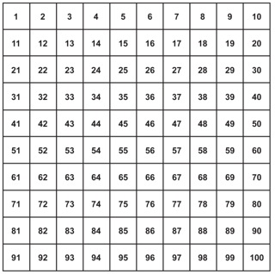 | Aids early counting. Excellent for adding and subtracting 10. Children can use this to find patterns in multiplication tables.
Place Value Counters  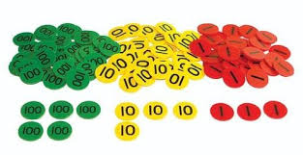 | Demonstrates how much a number is worth. Also used to partition numbers and add or subtract. Can be used to support children’s understanding of written methods e.g. column subtraction with regrouping. | 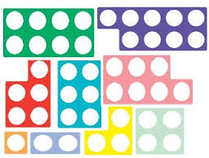  Numicon | Aids children in recognising how much a number is worth, ordering and comparing numbers. It can also be used to support children’s understanding in more complex areas such as multiplication, division and fractions.
Bead Strings | Bead strings are used for all four operations (addition, subtraction, division and multiplication). They are also used to count up in different amounts. | 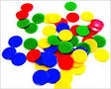  Counters/Cubes | Counters and cubes are used to aid children with counting.
Dienes/Base 10  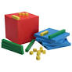 | Used to demonstrate a visual representation when understanding the value of numbers. Dienes/base 10 are related to each other in terms of size helping children to compare numbers. | Cuisenaire Rods  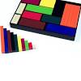 | Used in early KS1 to help children develop an understanding of the big ideas of equivalence and the part/whole relationship between numbers. Supports children’s understanding of bar models higher up in the school.
10 Frames  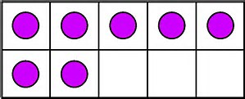 | Used to demonstrate a visual representation when understanding the value of numbers. Very useful for children to use when bridging to 10. | Number lines/Number Tracks  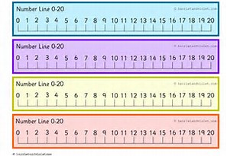  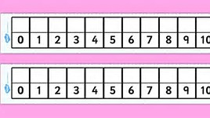 | Aids counting. Excellent for adding, finding the difference, multiplication as repeated addition and division as repeated subtraction. Chn can draw their own empty number lines to support all four operations.
Place Value Cards  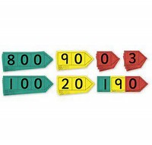 | Used to demonstrate a visual representation when understanding the value of numbers.

EYFS
Key Concepts
Through ensuring children have a thorough understanding of the fundamental principles of number (such as 1:1 correspondence and the cardinal principle) and have regular opportunities to develop fluency of number, Reception children are given a solid foundation in understanding the number system and counting, including an experience of addition, subtraction, doubling and halving in practical contexts.

Learning Milestone | Key concepts and ideas
Counting Strategies
Count items using 1:1 correspondence | Number sounds are clearly separated. Physical movement is linked to each number word, with exaggerated movement at first.
Count in a range of advanced contexts | Specific skills taught: 1:1, last number is total for set, count each object once (items in circle to add challenge). Extend by counting out objects from a larger set (‘get five spoons’), objects that can’t be moved, make objects not visible once counted (into a bag) or count sounds and movements.
Count on from large number when counting two sets | Introduced by counting two sets, then screening one of those sets to count on. Children learn the commutative law and to count on from the bigger number.
Numeral identification
Identify numerals 0-12 | Children match numerals to different representations of number e.g. making and finding four in different ways. Numerals and quantities matched in a range of contexts.
Identify numerals 0-20 | Teen taught as representing ten, e.g. fourteen as four and ten.
Identify numerals 0-100, discern teens/tens | Use of teen/ten visual cards for discerning teens/tens; place value arrow cards for partitioning and combining tens and units.
Concept of 10
Grasps 10 as a unit of ten ones | 10-sectioned egg boxes and 10-frames used e.g. positioning 12 counters onto two 10-frames.
Can add in groups of 10 | Counting supported by 100-square or Slavonic Abacus.
Understanding Quantity
Subitize instantly up to 3 objects | Taught discretely (e.g. dot pattern games) and practice in everyday situations. Progress to subitize unrelated items (e.g. a yellow frog, a toy car and a green cube).
Can discern between fingers and use fingers to show 1-10 | Able to perform simple tasks using all fingers (e.g. follow line). Show digit numbers in different ways using fingers.
Estimate small quantities with relative accuracy | Taught discreetly (e.g. dot pattern recognition in range 4-8) and built into everyday situations.
Break small quantities into two parts | Children break quantities into two groups visually (e.g. seeing 5 dots as 3 and 2). Instant recognition supported by use of 10-frame and fingers using sub-base 5 (e.g. seeing 7 as 5 and 2). Expectation of breaking down 0-5 in all ways, extend to 6-10 in different ways.
Number word sequences
Can perform forwards/ backwards sequences without dropping back | Songs and rhymes used. Children continue number sequences starting from different numbers and with some prior words in appropriate range e.g. 3, 4, 5, 6… or 24, 23… Focus placed on transition over 10s boundary, supported by visuals.
Early multiplication and division
Can halve and double shapes and quantities | 10-frames and Numicon used to for visual representations of half/double. Halves and doubles identified in a range of children’s contexts, with a focus on equal halves.
Shares items into groups of a given size / number of groups | Contexts provided for grouping as well as sharing. Example: ‘Each person needs three grapes for snack – there are enough grapes here for how many people?’
Count in steps of 2, 5 and 10 | Counting in 2s, 5s or 10s supported by 100-square or Slavonic Abacus. Opportunities given to calculate in context e.g. counting socks bundled in pairs.
Shape, space and measures
Can name 2D/3D shapes | Recognise shapes when rotated slightly. Spot shapes/combinations of shapes in everyday items.
Can order, compare and describe shapes and objects | Use language of size and position when describing shapes and objects. Experiences span length, height, weight and capacity, including irregular shapes e.g. differently shaped containers.
Use and solve problems with money and time | Use everyday language about time and money. Can find simple ways of measuring time; aware that coins represent different values. Match coins to visuals e.g. 1p-10p to Numicon pieces.
Recognise, create and describe simple patterns | Identify and create repeating patterns in a range of practical contexts. Describe ‘missing piece’ in pattern, extend by hiding more parts or create mirroring pattern (red, amber, green, amber, red…)
Extend number patterns | Show number patterns using visual representations. Identify, describe and extend patterns.

EYFS
Suggested Visual Representations to Support Children’s Understanding

Counting Strategies
Progress to counting sets that can’t be move, where children have to keep track of counted/not counted items |  |  |  | When counting two sets, children learn to count on by screening the first set once counted.  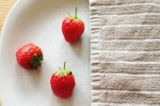
Numeral identification
Numerals and quantities matched in a range of contexts.  Numicon, finger patterns, 10-frame images, regular and irregular dot patterns. | Teen/ten visual cards for teen numbers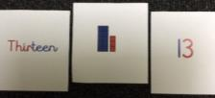. |  |  |  | Place value arrow cards for partitioning and combining tens and units.  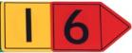
Concept of 10
Items counted/bundled into 10  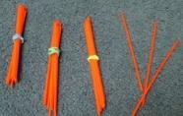 | 10-frames and 10-frame egg boxes used e.g. positioning 12 counters onto two 10-frames.  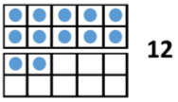 |  |  |  | Counting supported by 100-square.  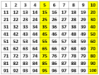
Understanding Quantity
Subitize regular and irregular dot patterns, recognising quantity without counting. |  |  | Show digit numbers in different ways using fingers.  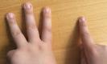 |  | Instant recognition of numbers up to 10 using 10-frame.  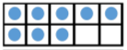
Number word sequences
Transition over 10s boundary supported by using part of number track.
Early multiplication and division
10-frames and Numicon used to for visual representations of half/double.  Double 4  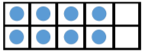 |  | Count in steps of 2, 5 and 10 supported by 100-square and Slavonic Abacus. |  |  | Equal grouping supported by visuals.  5 people in each tent  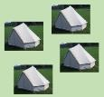

EYFS
Daily Fluency

Counting
- Use language of sequencing and chronology [before and after, next, first, today, yesterday, tomorrow, the days of the week, morning, afternoon and evening.
- Count forwards and backwards in 1s from any number up to 20.
- Play track games where children roll a die marked with 1 or 2 and move forward either 1 or 2, winning when they reach 20.
- Sing counting songs and use visuals and resources matching the numbers that are being sung.
- Count sets of objects from 1 to 20

Number facts
- Subitise numbers to 6 using dice patterns and numbers to 5 then 10 using five/ten frames or Numicon
- https://www.youtube.com/watch?v=zZ_Jsy4q-hY = domino/dice patterns 1-6 https://www.youtube.com/watch?v=aRgcWtvTHJE&list=PLfHb7QwGAgCSYxOuqd9iJoNqGfvCoD9Xp&index=5 = 5 frame flash
https://www.youtube.com/watch?v=wRR9LK3zfho = ten frame flash
- Recall and use addition facts to 10, then to 20 focusing on teen numbers.
- Have a number of the week, a number table and lots of representations of that number. Find all the bonds to that number and call this the ‘story of’ the number e.g. The story of 5 is 0 + 5, 1 + 4, 2 + 3 (see image on below)
- Learn and recall number bonds to 10 – the story of 10
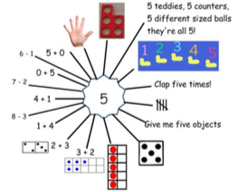
- Know doubles and halves (of even numbers) up to 12

Place value
- Place numbers from 1 – 20 in order
- Compare amounts of objects and numbers and say which is
greater than > or less than < or equal to =

Year 1
Suggested Visual Representations to Support Children’s Understanding

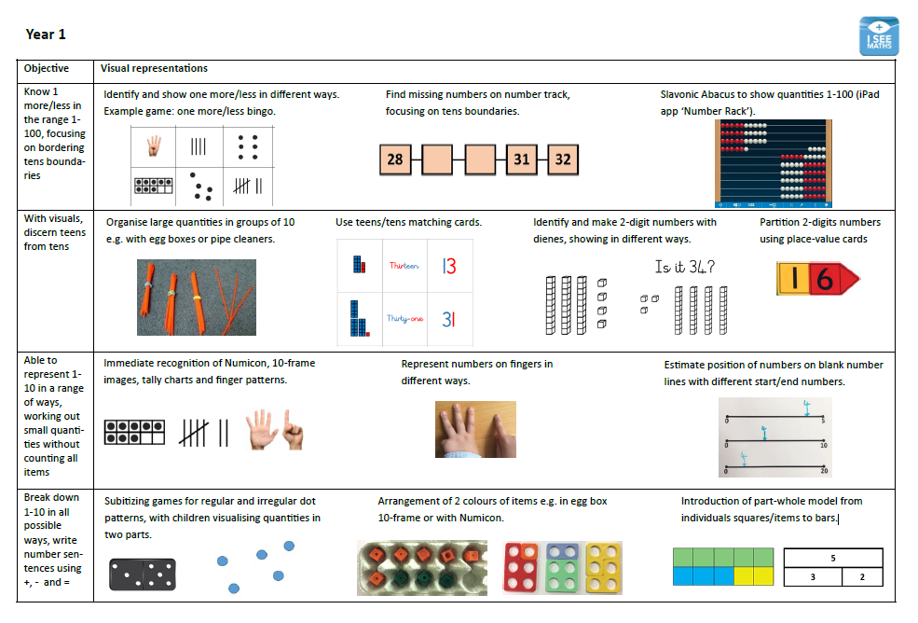
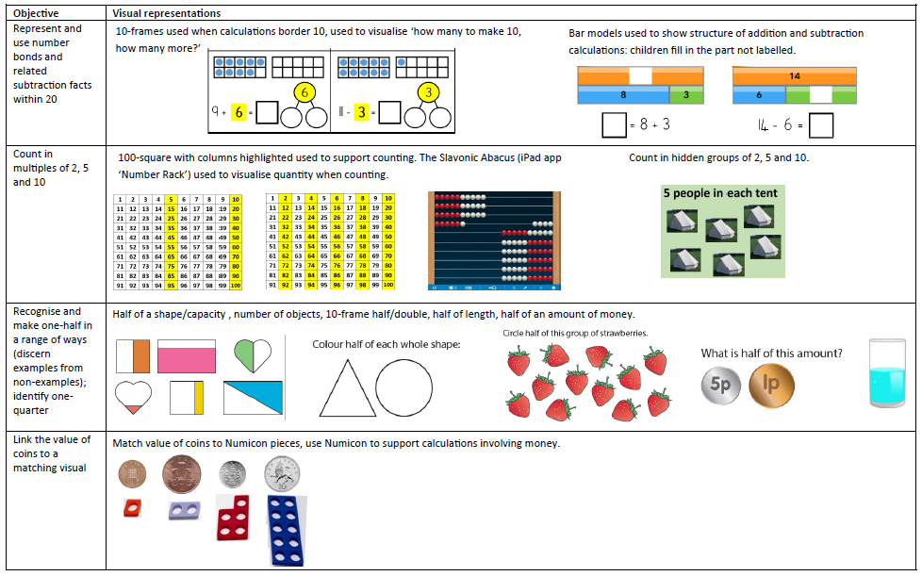

Year 1
Daily Fluency

Counting
- Use language of sequencing and chronology [before and after, next, first, today, yesterday, tomorrow, the days of the week, morning, afternoon and evening.]
- Count forwards and backwards in 1s from any number up to 100.
- Play games where children roll a die marked with 1 or 2 and move forward either 1 or 2, winning when they reach 20.
- Count to 100 in 10s, forwards and backwards
- Count to and across 100, forwards and backwards, beginning with 0 or 1, or from any given number.
- Count on or back in 10s (call this ‘spider counting’ and use a 100 square.) Encourage children to add or subtract nearly numbers such as 11 and 9 once confident.
- Find rules and missing numbers in additive sequences where the ‘empty boxes’ are different shapes
- Count in halves up to 10, starting from any number using a counting stick.
- Count in 10s, 5s and 2s and tally in 5s ; Count in 5s round a clock face to 60 minutes; Count in steps of 3.
- Count in steps of 5p, 20p and 10p etc. to support money work.

Number facts
- Subitise numbers to 6 using dice patterns and numbers to 5 then 10 using five/ten frames or Numicon
https://www.youtube.com/watch?v=zZ_Jsy4q-hY = domino/dice patterns 1-6 https://www.youtube.com/watch?v=aRgcWtvTHJE&list=PLfHb7QwGAgCSYxOuqd9iJoNqGfvCoD9Xp&index=5 = 5 frame flash https://www.youtube.com/watch?v=wRR9LK3zfho = ten frame flash
- Recall and use addition and subtraction facts to 20 fluently, and derive and use related facts up to 100
- Rehearse/secure rapid recall of + and – facts for all numbers to 20 not just totals to 10 and 20 e.g. numbers which total 8, 9, 11, 15 etc. Call these the ‘stories of numbers’ and have a number of the week/day. Encourage children to ‘calculate’ not ‘count’ when they are secure in number facts and can use these.
- Rapidly recall/memorise doubles and halves (of even numbers) to 20; examine this inverse relationship.
- Learn and recall number bonds to 100, with multiples of 10
- Use mental addition and subtraction strategies e.g. doubles and near doubles e.g. 4 + 4 = 8 so 4 + 5 = 9

Place value
- Finding ‘half of...’ a line or ‘half way between’
- Make and compare numbers using digits cards, > < and = symbols

Year 2
Suggested Visual Representations to Support Children’s Understanding

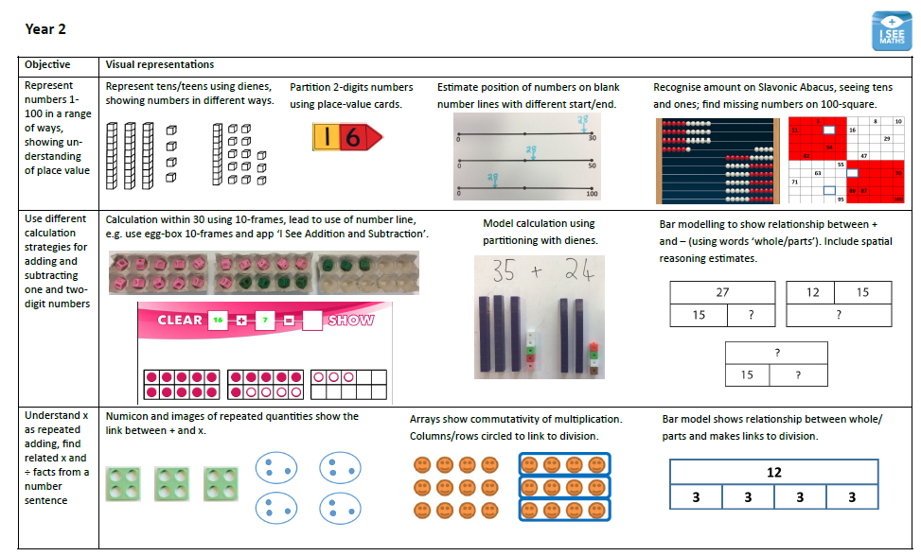
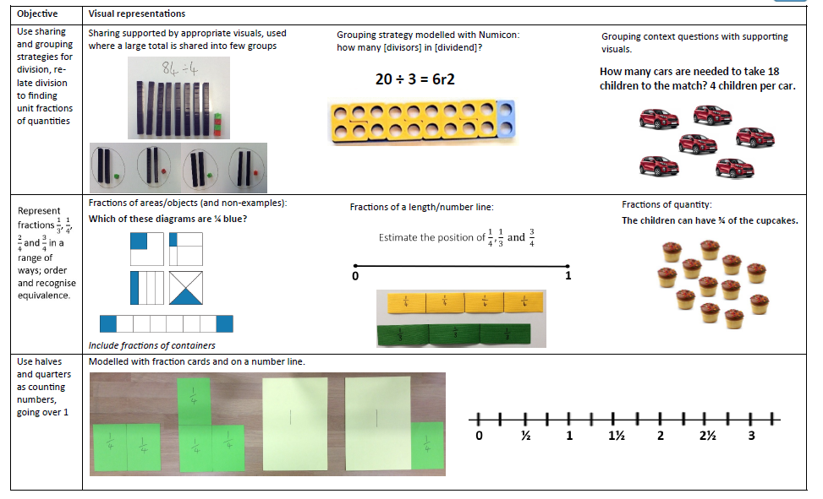

Year 2
Daily Fluency

Counting
- Count in steps of 2, 3, 5 and 10 at first from 0 and then from any number, forward or backward. Tally in 5s.
- Find rules and missing numbers in additive sequences e.g. 5, 10, 15, ?
- Count in fractions beyond one whole, starting from any number and using the1/2 and 2/4 equivalence on the number line
- Use a counting stick to count in 1/4s beyond 1 whole! Discuss equivalence... how else could we say 2/4?
- Count in steps of 5p, 20p and 10p etc. to support money work.

- Number facts
- Recall and use addition and subtraction facts to 20 fluently, and derive and use related facts up to 100
- Find rules and missing numbers in additive sequences.
- Recall number bonds to 100, starting with multiples of 10, then multiples of 5, then any numbers.
- Double numbers to 10 and halve numbers to 20; examine this inverse relationship and relating this to the 2X table.
- Chant 5X and 10X tables, making links between the two.
- Chant 2X and 4X tables, making links between the two.
- Recognise and use the symbols for pounds (£) and pence (p) and read amounts of money.
- Recognise and use the symbols for millilitres and litres; grams and kilograms. Read different measures.
- Use mental addition and subtraction strategies:
  - - Use the ‘story of’ numbers/number bonds and their inverses, especially to 10 and 20.
  - - Quick adds e.g. 20 + 7 then 23 + 6 ‘because I know 3 + 6 = 9’
  - - Partitioning single digit numbers in different ways to bridge 10 e.g. 27 + 5 = 27 + 3 + 2
  - - Add multiples of 10 and nearly numbers like 19 by spider counting and adjusting.
  - - Doubles and near doubles e.g. 4 + 4 = 8 so 4 + 5 = 9
  - - Adding strings of numbers by making bonds or finding doubles.
- Begin doing regular mini-tests which focus on addition and subtraction using these strategies alongside quick recall. Encourage children to try to improve their P.B. within a time limit.

    - Place value
- Find ‘half of...’ a line, piece of string etc. or ‘half way between’ two points, people, or numbers, starting with half way along a 0-10 number line, then 0-100 number line.
- Estimate where to put a number on a number line with different start and end points (up to 100)
- Know which multiples of ten are before or after a number. Find the next multiple of 10 and say how many more to get there.
- Know the value of each digit in a two-digit number (tens and ones)
- Make and compare numbers using digits cards, > < and = symbols

Year 2 - 6
Simple Progression in Written Methods for Addition

Children need to be able to:  - recall addition pairs to 9 + 9  - know all complements to 10  - add mentally a series of single- digit numbers, such as 5 + 8 + 4  - count on in 1s, 10s and 100s  - partition numbers in ways other than into tens and ones to help with bridging multiples of 10 and 100 | Children need to be able to:  - partition numbers into hundreds, tens and ones  - recall addition pairs to 9 + 9  - add multiples of 10 or 100 (such as 60 + 70 or 600 + 700) using a related fact (6 + 7) and knowledge of place value  - mentally add multiples of 100, 10 and 1 e.g. 800 + 130 + 12
 | Stage 2: Partitioning  When adding larger numbers, it becomes less efficient to count on so partitioning is used.  Partition into (hundreds) tens and ones, add to form partial sums and then recombine.  Partitioning all the numbers mirrors the standard column method where ones are placed under ones and tens under tens etc.  Example:  Partitioned numbers are written under one another:  47 + 76 =40 + 7  =70 + 6  110 + 13 = 123  375+567=300 + 70 + 5  500 + 60 + 7  800 + 130 + 12 = 942 | Stage 3: Expanded column method  The expanded method leads children to the more compact column method so that they understand the structure and efficiency of it.  The amount of time that should be spent teaching and practising the expanded method will depend on how secure the children are in their recall of number facts and in their understanding of place value.  Example:  Write the numbers in columns:  Add the ones first  47  + 76  13  110  123  Discuss how adding the ones first gives the same answer as adding the tens first. Refine over time to consistently adding the ones digits first.  The addition of the tens in the calculation 47 + 76 is described as ‘Forty plus seventy equals one hundred and ten’, stressing the link to the related fact ‘Four plus seven equals eleven’. | Stage 4: Column method  The method is then shortened and when the column total is a two-digit number, the tens (or hundreds) are carried over into the next column. Use the words ‘carry ten’ or ‘carry one hundred’, not ‘carry one’.  Example:  366  + 458  824  1 1  Once learned, this method is quick and reliable.  Later, extend to adding three two-digit numbers, two three-digit numbers, and numbers with different numbers of digits. This method of can also be used to add decimals.
Stage 1: Empty number line

The empty number line helps to record the steps on the way to calculating the total. The steps often bridge through a multiple of 10.

Example:

48 + 36 = 84

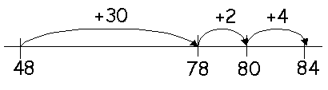

or: 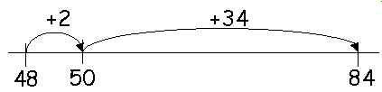

Year 2 - 6
Simple Progression in Written Methods for Subtraction

Children need to be able to:  - recall all addition and subtraction facts to 20;  - subtract multiples of 10 (such as 160 – 70) using the related subtraction fact (16 – 7) and their knowledge of place value  - know all complements to 10 and 100 | Children need to be able to:  - partition two-digit and three-digit numbers into multiples of one hundred, ten and one  - partition numbers in different ways. e.g. 74 into 70 + 4 or 60 + 14  - subtract mentally a single-digit number or a multiple of 10 from a two-digit number  - add the totals (of the hundreds, tens and ones columns) mentally
Stage 1: Empty number line  Empty or numbered lines are a useful way of modelling processes such as bridging through multiples of ten. The steps can be recorded by counting on or back.  Find the difference by counting on: 74 – 27 = 47  326 – 178 = 148  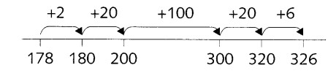  Counting back example: 15 – 7 = 8  74 – 27 = 47  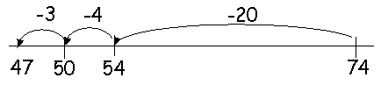  The steps may be recorded in a different order or combined. With practice children will record less information and decide whether to count on or back | Stage 2: Expanded method for column subtraction | Stage 3: Decomposition
 | Example  Set calculation out as below. Partition both numbers by splitting into one and tens. Start subtraction from ones column and move left  70 + 4  20 + 1 -  50 + 3 = 53  Add numbers at end to find the answer. | 6714  −2 7  4 7  Say, “60 – 20” or, “6 tens – 2 tens” not, “6 – 4”
 | Example with exchanging  Set calculation out as below. Partition both numbers by splitting into one and tens. Start subtraction from ones column and move left. Borrow from next column if necessary e.g. exchange one ten for ten ones.  ⁷⁰  80 + ¹2  20 + 7 -  50 + 5 = 55  Add numbers at end to find the answer. | 4516 3  - 2 7 1  2 9 2  Say, “60 – 20” or, “6 tens – 2 tens” not, “6 – 4”

Year 2 - 6
Simple Progression in Written Methods for Multiplication

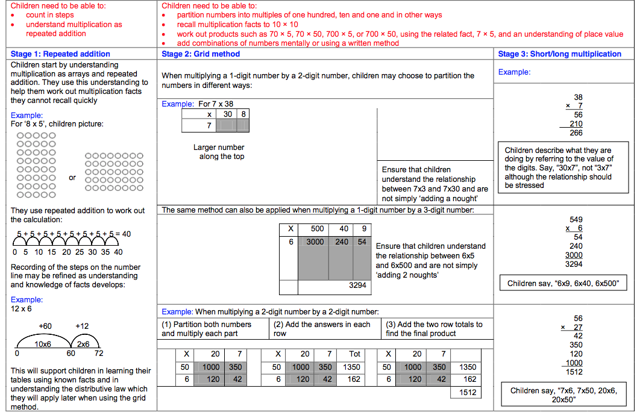

Year 2 - 6
Simple Progression in Written Methods for Division

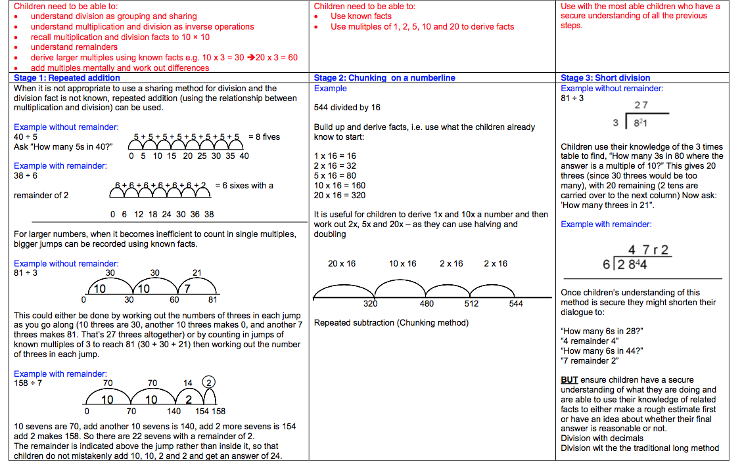

Year 3
Suggested Visual Representations to Support Children’s Understanding

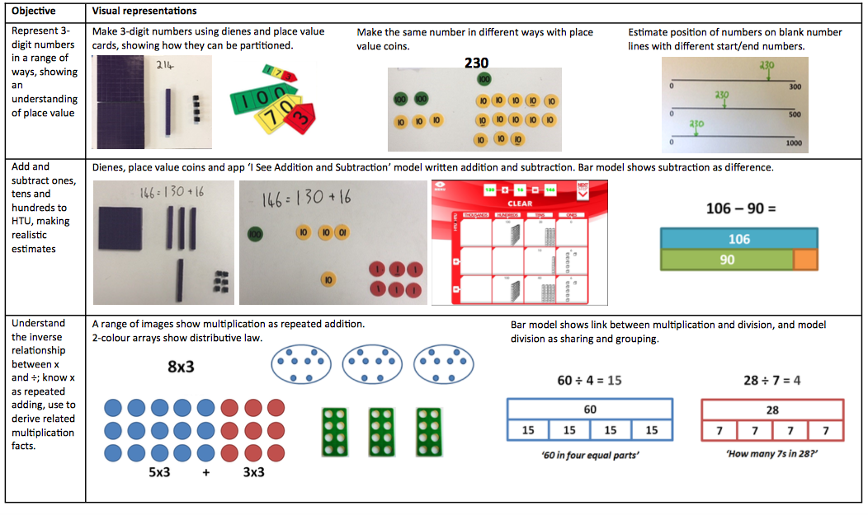
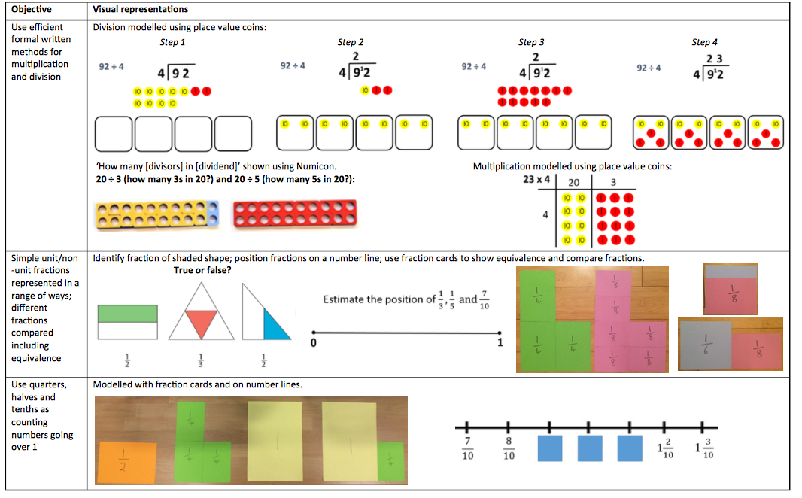

Year 3
Daily Fluency

Counting
- Count in steps of 2, 3, 4, 5, and 10 at first from 0 and then from any number, forward or backward. Tally in 5s.
- Count from 0 in steps of 4, 8, 15, 20, 25, 50 and 100
- Find rules and missing numbers in additive sequences and on number lines and scales.
- Count up and down in fractions beyond one whole, starting from any number and using the 1/2 and 2/4 equivalence on the number line, then count in 1/4s, and later 1/10s.
- Read and convert between mixed numbers and improper fractions.

Number facts
- KS1 review: use mental addition strategies without counting on! Calculate don’t count:
  - Bonds to 10, 20, 100 (the latter using multiples of 10 and 5) with fluency!
  - Quick adds e.g. 20 + 7 then 23 + 6 ‘because I know 3 + 6 = 9’
  - Partitioning single digit numbers in different ways to bridge 10 e.g. 27 + 5 = 27 + 3 + 2
  - Add multiples of 10 and nearly numbers like 19 by spider counting and adjusting.
  - Doubles and near doubles e.g. 4 + 4 = 8 so 4 + 5 = 9
  - Adding strings of numbers by making bonds or finding doubles.
- Solve empty box/missing number problems including those with inequalities, using mental strategies of + and -
- Double numbers to 10 and halve numbers to 20 rapidly. Then double two digit numbers mentally by partitioning, first without bridging then with bridging.
- Chant 3 and 6 X tables, and 4 and 8 X tables; review 2, 5 and 10 X tables from Y2. Do mini-tests/quick quizzes targeting the times table of the week or a mixture of known times tables.
- Find division facts by using the inverse of known times tables.
- Find 1⁄2 or 1⁄4 of a number or shape.
- Compare measures of mass (kg/g) and volume/capacity (l/ml).

Place value
- Find ‘half way between’ two numbers, starting with multiples of 10. Begin to know important landmarks, such as 50 is half of 100, 25 is half of 50, 500 is half of 1,000.
- Know which multiples of ten are before or after a number. Say how many to go back or count on to these multiples of ten, and which is closer.
- Read and write numbers up to 1,000 in numerals and in words, noting the pattern of three digits and commas.
- Know the value of each digit in a three-digit number (hundreds, tens and ones)
- Estimate where numbers with up to 3 digits should be placed on different number lines with different start and end points.
- Make and compare numbers using digits cards, > < and = symbols
- Multiply numbers by 10 (to support the beginning of conversions and multiplication of one digit by two digit numbers).

Year 4
Suggested Visual Representations to Support Children’s Understanding

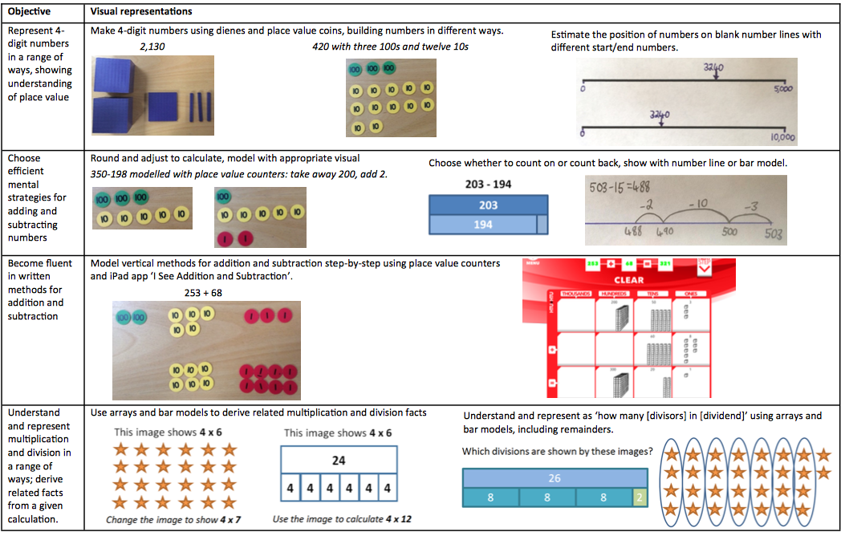

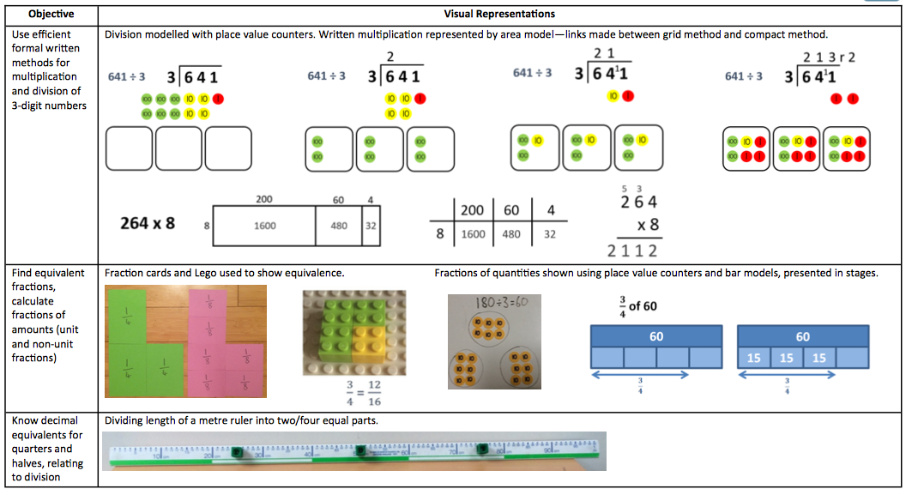

Year 4
Daily Fluency
Counting
- Count in steps of 2, 3, 4, 5, and 10 at first from 0 and then from any number, forward or backward. Tally in 5s.
- All sorts of step counting, going up (or down) in... 5, 6, 7, 9, 10, 15, 19, 21, 25, 15, 30, 50, 60, 100 and 1,000.
- Find rules and missing numbers (including fractions) in additive sequences and on number lines and scales.
- Count up and down in fractions beyond one whole, starting from any number and exploring equivalence as you go. Count in 1/2s and 1/4s, 1/5s and 1/10s, 1/3s.
- Read and convert between mixed numbers and improper fractions.
- Count in 0.1s, 0.01s and 0.5s
- Divide multiples of 100 by 20 and 25 by chunking in 20s and 25s.
- Count in steps of 5 or 10 degrees

Number facts
- KS1/Y3 review: mental addition strategies without counting on! Calculate don’t count:
  - Bonds to 10, 20, 100 with fluency!
  - Quick adds e.g. 20 + 7 then 23 + 6 ‘because I know 3 + 6 = 9’
  - Partitioning single digit numbers in different ways to bridge 10 e.g. 27 + 5 = 27 + 3 + 2
  - Finding near doubles rather than adding e.g. 30 + 31
  - Adding multiples of 10 and nearly numbers like 19 by spider counting and adjusting.
  - Add strings of numbers by finding bonds and doubles.
- Memorise/chant 7, 9, 11 and 12 times tables; rehearse and chant all times tables learnt in previous years.
- Link thinking using known facts e.g. If I know 6 X 7 = 42, I know 60 X 7 = 420; If I know 2 X 4 = 8, I know 20 X 4 = 80; If I know 5 X 6 = 30 I know 30 ÷ 5 = 6
- Double and halve two and three digit numbers mentally by partitioning and recombining (not too much bridging if done mentally!)
- Find rules and missing numbers in multiplicative/doubling or halving sequences.
- Compare measures of mass (kg/g) and volume/capacity (l/ml).
- Find unit fractions of numbers.

Place value
- Find ‘half way between’ two numbers, starting with multiples of 10. Begin to know important landmarks, such as 50 is half of 100, 25 is half of 50, 500 is half of 1,000.
- Estimate where numbers with up to 4 digits should be placed on different number lines with different start and end points.
- Know which multiples of 10 or 100 are before or after a number to help with rounding. Say how many back or on to these multiples of 10 or 100, and which is closer.
- Read and write numbers up to 1,000 in numerals and in words, noting the pattern of three digits and commas.
- Multiply and divide numbers by 10, 100 and 1,000. Divide numbers by 10 which become 1 place decimal numb

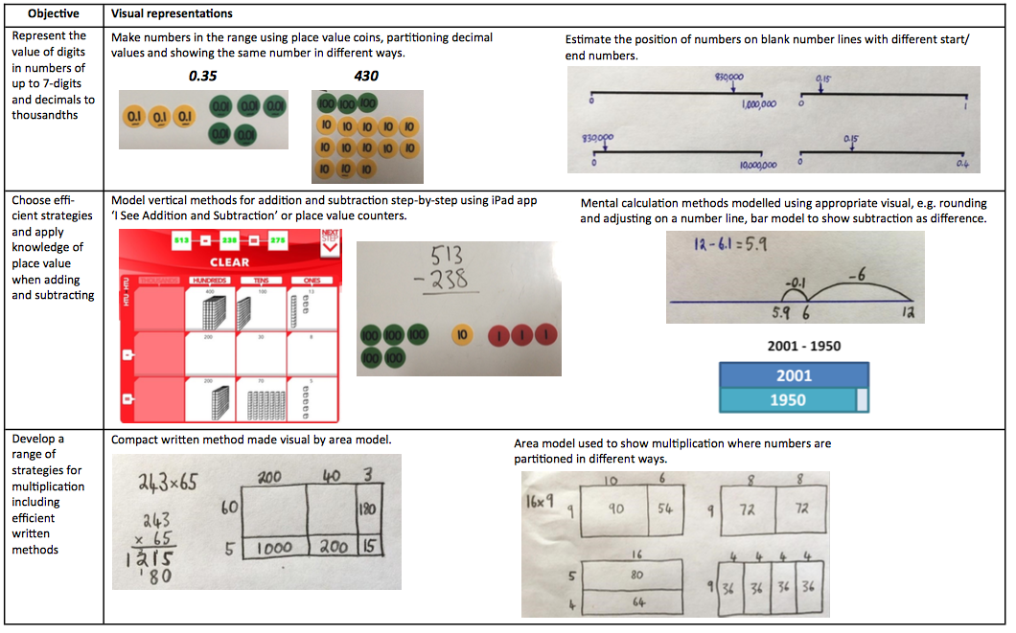
Year 5
Suggested Visual Representations to Support Children’s Understanding

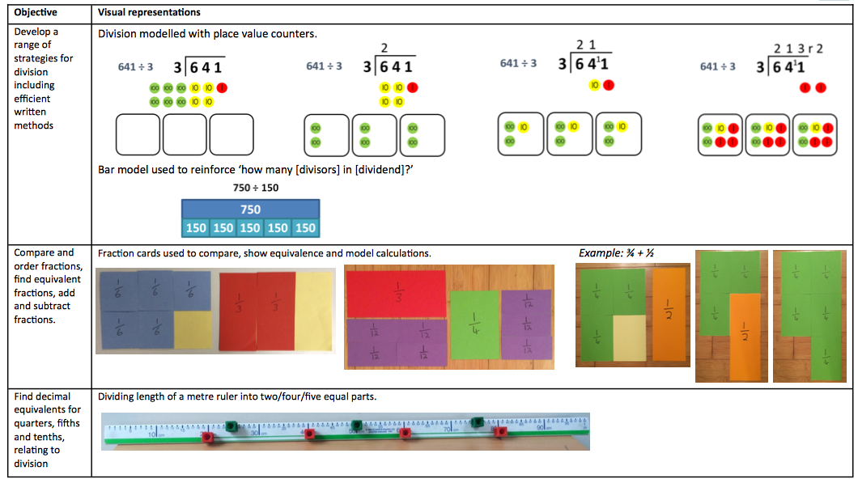

Year 5
Daily Fluency
Counting
- Count forwards or backwards in steps of powers of 10 for any given number up to 1,000,000.
- All sorts of step counting, going up (or down) in ... 5, 6, 7, 9, 10, 15, 19, 21, 25, 15, 30, 50, 60, 100 and 1,000. Depending on fluency, begin on different numbers.
- Count in intervals which will relate to measuring scales or graph axes’ increments ie. Counting in 25s.
- Count in decimals in small steps from 0.001 to 0.1
- Count up and down in fractions beyond one whole, starting from any number and exploring equivalence as you go. Count in 1/4s, 1/5s and 1/10s, 1/3s and 1/6s.
- Read and convert between mixed numbers and improper fractions.
- Find rules and missing numbers in additive sequences and on number lines and scales.
- Count in steps of 5 or 10 degrees until you reach 360 degrees.

Number facts
- Be explicit with children about using and practising mental strategies of addition and subtraction. Give them mini-quizzes which test these strategies:
  - Using bonds to 1, £1, 10, 20, 100 with fluency!
  - Quick adds e.g. 2 + 0.7 then 2.3 + 0.6 ‘because I know 0.3 + 0.6 = 0.9’
  - Partitioning single digit numbers in different ways to bridge 10 e.g. 27 + 5 = 27 + 3 + 2; linking this to bridge whole numbers when adding or subtracting decimals. ✓ Finding near doubles rather than adding e.g. 30 + 31; linking this to decimal work to add 3 and 3.1
  - Adding multiples of 10 or 100 and nearly numbers like 19 by spider counting and adjusting.
  - Add strings of numbers by finding bonds and doubles.
- Memorise/chant all times tables learnt in previous years.
- Do mini-tests/quick quizzes targeting the times table of the week or a mixture of known times tables. Keep re-assessing missing facts.
- Link thinking using known facts e.g. If I know 6 X 7 = 42, I know 60 X 7 = 420; If I know 2 X 4 = 8, I know 20 X 4 = 80; If I know 5 X 6 = 30 I know 30 ÷ 5 = 6
- Find unit and non-unit fractions of numbers.
- Chant/recall square numbers to 144 and smaller cube numbers; chant prime numbers to 20 then to 100.
- Use mental strategies for multiplying and dividing 4 (e.g. double and double) by 5 (e.g. X 10 and halve)
- Find rules and missing numbers in multiplicative/doubling or halving sequences including term to term sequences.
- Rehearse geometric vocabulary and the properties of shapes.

Place value
- Find ‘half way between’ two numbers on a line. Use important landmarks such as 50 is half of 100, 25 is half of 50, 500 is half of 1,000, 75 is 3⁄4 of 100, 750 is 3⁄4 of 1,000.
- Estimate where numbers with up to 6 digits and three decimal places should be placed on different number lines.
- Put decimal numbers with different numbers of decimal places (one or two places) in order or compare two decimal numbers using > and <
- Know which multiples of 10, 100 or 1,000 are before or after a number. Say how many to go back or count on to these multiples, and which is closer, rounding.
- Read and write numbers up to 1,000,000 in numerals and in words, noting the pattern of three digits and commas.
- Complete equations with digit cards to make them correct i.e. Using > < and =
- Multiply and divide numbers by 10, 100 and 1,000. Divide numbers by 10 which become 1 place decimal numbers.

Year 6
Suggested Visual Representations to Support Children’s Understanding

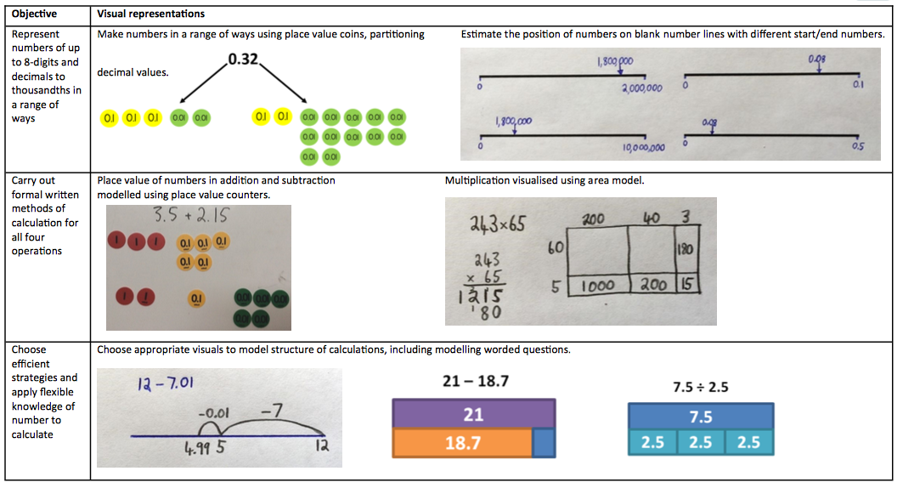

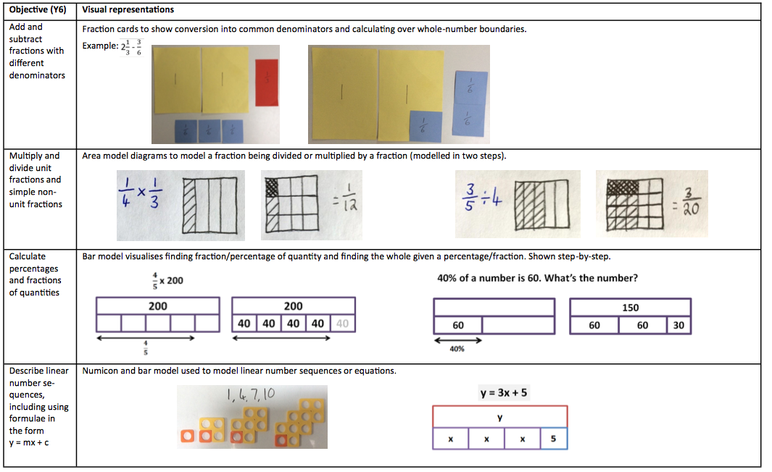

Year 6
Daily Fluency

Counting
- Count forwards or backwards in steps of powers of 10 for any given number up to 10,000,000.
- All sorts of step counting, going up (or down) in ... 5, 6, 7, 9, 10, 15, 19, 21, 25, 15, 30, 50, 60, 100 and 1,000.
- Count in intervals which will relate to measuring scales or graph axes’ increments i.e. Counting in 25s.
- Count in decimals in small steps from 0.001 to 0.1
- Count up and down in fractions beyond one whole, starting from any number and exploring equivalence as you go. Count in 1/4s, 1/5s and 1/10s, 1/3s and 1/6s.
- Read and convert between mixed numbers and improper fractions; simplify fractions.
- Find rules and missing numbers in additive sequences and on number lines and scales.

Number facts
- Be explicit with children about using and practising mental strategies of addition and subtraction. Give them mini-quizzes which test these strategies:
  - Using bonds to 1, £1, 10, 20, 100 with fluency!
  - Quick adds e.g. 2 + 0.7 then 2.3 + 0.6 ‘because I know 0.3 + 0.6 = 0.9’
  - Partitioning single digit numbers in different ways to bridge 10 e.g. 27 + 5 = 27 + 3 + 2; linking this to bridge whole numbers when adding or subtracting decimals. ✓ Finding near doubles rather than adding e.g. 30 + 31; linking this to decimal work to add 3 and 3.1
  - Adding multiples of 10 or 100 and nearly numbers like 19 by spider counting and adjusting.
  - Add strings of numbers by finding bonds and doubles.
- Memorise/chant all times tables learnt in previous years.
- Do mini-tests/quick quizzes targeting the times table of the week or a mixture of known times tables. Keep re-assessing missing facts.
- Link thinking using known facts e.g. If I know 6 X 7 = 42, I know 60 X 7 = 420; If I know 2 X 4 = 8, I know 20 X 4 = 80; If I know 5 X 6 = 30 I know 30 ÷ 5 = 6
- Identify factors and common factors of composite numbers.
- Find rules and missing numbers in multiplicative/doubling or halving sequences.
- Chant/recall square numbers to 144 and smaller cube numbers; chant prime numbers to 20 then to 100.
- Use mental strategies for multiplying and dividing 4 (e.g. double and double) by 5 (e.g. X 10 and halve) and by 25 (e.g. X 100 then halve and halve again)
- Find the mean as an average of a list of numbers.
- Rehearse geometric vocabulary and the properties of shapes.

Place value
- Find ‘half way between’ two numbers on a line. Use important landmarks such as 50 is half of 100, 25 is half of 50, 500 is half of 1,000, 75 is 3⁄4 of 100, 750 is 3⁄4 of 1,000.
- Estimate where numbers with up to 6 digits and three decimal places should be placed on different number lines with different start and end points.
- Put decimal numbers with different numbers of decimal places (one, two or three places) in order or compare two decimal numbers using > and <
- Know which multiples of 10, 100 or 1,000 (or whole numbers) are before or after a number. Say how many back or on to these landmarks, and which is closer, rounding.
- Read and write numbers up to 10,000,000 in numerals and in words, noting the pattern of three digits and commas.
- Complete equations with digit cards to make them correct i.e. Using > < and =
- Multiply and divide numbers by 10, 100 and 1,000. Divide numbers by 10 which become 1 place decimal numbers.

